Search category configuration is accessible only during an active search. Once configured, the new settings will apply to all future searches.
Use these instructions to configure the search categories, specifically to display student information first.

INSTRUCTIONS

- In the toolbar, conduct a search.

The information in the search is unimportant. By conducting a search, the search settings become available. In this example, the search is for a test student.

- Click “Configure Search”

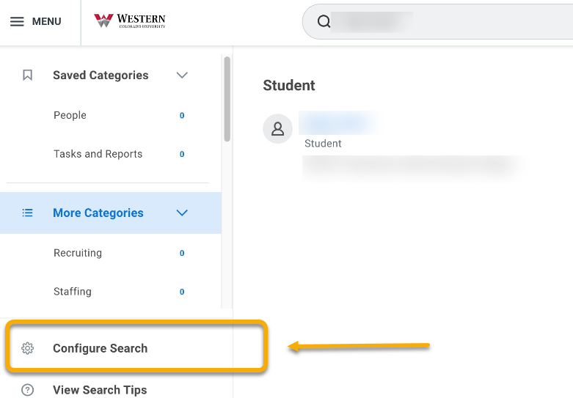

- Locate “Student” and drag “Student” to the top under the “Saved Categories” heading. This allows for students to be prioritized in future search results

Locate “People” and drag “People” to the bottom under the “More Categories” heading. This gives less priority to institution employees in future search results.

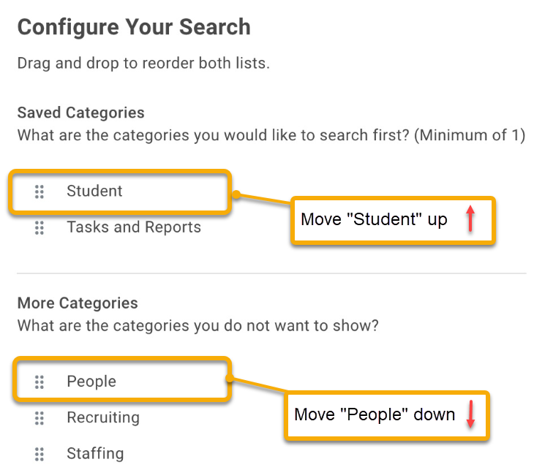
.

- When finished, click “Save”.

